(Approx. 1,318 words)

Note: This article was divided between two monthly newsletters. You may edit it for one continuous article, if you wish.

Careful What You Ask For!
By Richard Kennon, Newsletter Editor, Amador Computer Users Group, California
www.acug.net/
editor(at)acug.org

Obtained from APCUG with the author's permission for publication by APCUG member groups.

This last Christmas I asked Santa for a nineteen inch wide-screen, thin, flat display for my computer. Santa, being busy and not knowing a thing about computers, asked our son to make the purchase. He decided that nineteen inch was for wimps so he picked up a twenty-two inch wide-screen. It is a beauty with 1680x1050, 96ppi resolution. That is super good… except. Wouldn’t you know, my old Dell has a video card that does not go that high. So, buy a new video card, right? They are not so expensive. It turns out my old Dell does not have a slot to unplug the card and plug in a new one. I am not sure of the technicalities, but one tech suggested a new mother board as well. They are not too expensive either. Then his partner says, “If you are going to spend that much, why not let us build you a new computer for just a little more?” Golly, what a great idea. The old Dell is getting so slow, I am frustrated every time I use it. So, why not get a new supercharged dual processor and two gigs of RAM so I can really sail? We discussed specifications for a while and came to agreement. Then I said I would want the Vista Home Premium operating system. One of the partners said, “Why don’t you stick with XP?”

What follows is not what he said but I figured out later that this is what he was thinking. “This old geezer is probably not going to outlast XP so why burden him with a new operating system that just eats up processor power and RAM without offering any benefit? He is going to continue to do the same things he has always done on the computer so why not let him enjoy the benefits of all this new horsepower without the burden of having to learn about a new operating system?”

Out loud he said, “This will allow you to use all the software you now have and won’t require you to download all new drivers, etc.” I had already decided I could not afford a new version of MS Office and would convert to Open Office, instead. There is no Publisher in Open Office so I would have to do something, I hadn’t figured out yet, to continue publishing this newsletter. This idea gave me a great sense of relief - I could reap the benefits of the newer, faster hardware without having to give up software I have grown used to. A little extra icing on the cake is that they will transfer all my Outlook Express folders and address book to the new box so I won’t have to figure that out. Also, I have an 80 GB second hard drive in the old box that they will mount in the new. I use it for backup. The new main hard drive will be a 250 GB SATA drive and the second drive can remain an IDE drive. I haven’t the slightest idea what that means except that SATA is supposed to be faster and they can mix the two types on one machine.

I am anxiously awaiting delivery of the new computer and will report next month on how it all works out. So, I have spent our Federal rebate already. You can’t say I am not patriotic!

Careful What You Wish For, II
By Richard Kennon

I got it! Wow, it looks just like every other computer. Perhaps you will remember last month I reported I had received a new Samsung 22-inch wide screen display that my old computer would not feed. One thing led to another and I commissioned a local computer store to build a new computer for me. It has a 250 Gbyte SATA hard drive, 2 Gbyte RAM and an AMD 64x2 dual processor. Also, it is loaded with XP Home operating system. I went into the ‘why’ last month. I was so proud of my smarts when I copied all “My Documents” to an 80 Gbyte backup hard drive and then had the store transfer this drive to the new box. But, when I went to access it, the latest copy had not taken. Bummer! Then I started to copy the files onto a flash drive to transfer them. About that time the old computer went bonkers - out of spite, I suppose. After many tries I got most of what I wanted transferred. I won’t bore you with sordid details.

The first priority was to load the McAfee firewall and virus protection. I went to the McAfee site and mucked around for a while and finally got into a chat with someone called, Anish, on the other side of the globe, probably. He offered to help and led me through the most complicated procedure I have ever followed including typing Windows-R and typing in “%temp%.” Then he said to delete all the files that popped up. There were about 250 files and perhaps 10 or 20 did not wish to be deleted. Every time I got to one that would not be deleted, I clicked ‘OK’ and had to start over again. After we finally got through that, he gave me a web site to access and everything went smoothly from there.

The next anguish was trying to load the HP printer drivers for my two printers. That appeared to go well at first but later something went very wrong and Microsoft volunteered that the problem was caused by Hewlett Packard and that HP had a fix on a site I could click to. That is really nice service! So, I did everything the HP site said to do but it kept failing with a message outlining three possible causes – none of which seemed to apply from the best I could determine. At that juncture, I decided to drop back to square-one and try to reload the driver in question from the disk. First, it was necessary to uninstall the driver and then re-install it. I did this but failed to read the fine print. It is clear now that one cannot install the driver if the printer is plugged into the computer. So, uninstall and re-install again but do it right this time, dummy. What do you know? It worked!

I reloaded MS Office 2003 Professional that I had been using for some time. That went quite well. Then I downloaded Service Pack 2 (or, is it 3?) and the Compatibility Pack I wrote about last month. That went well, also. It is interesting how even old people can learn, isn’t it?

Next came Photoshop Elements 5.0 and after that will come TOPO!, which is a map program I like and several other smaller programs, including my Nikon camera software.

All in all, it has been not as bad an experience as it might have been and not as good as wished for. The backup hard disk is/was a great idea but somehow I fumbled the execution. My only advice is that if you want to get a new computer, plan, plan, plan and then consult as many others, who might have gone through it, as possible.
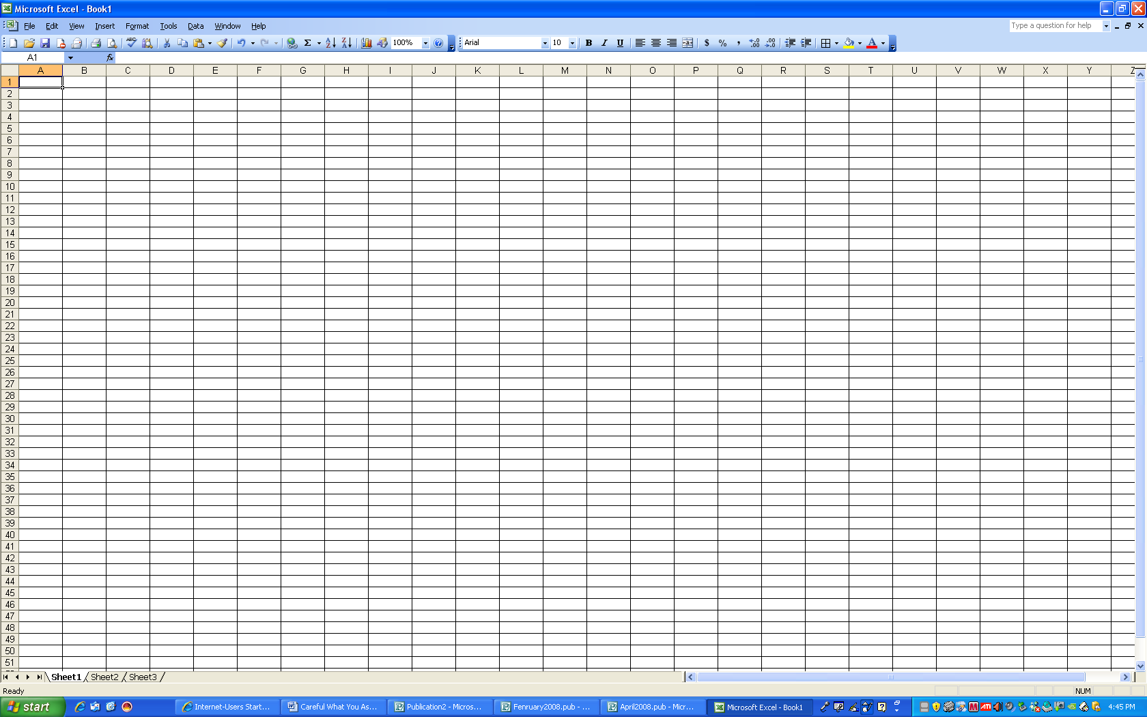

How about that? Twenty five and a half columns!

This article may be used in any non-profit publication if credit is given to the author and the Amador Computer Users Group of Jackson, California.

This article has been provided to APCUG by the author solely for publication by APCUG member groups. All other uses require the permission of the author (see e-mail address above).

